EXPERIMENT 5B
DATA VISUALIZATION AND ANALYSIS – FIFA WORLD CUP 2026 PLAYER PERFORMANCE
Aim
To analyze FIFA World Cup 2026 player performance data using Pandas and create different visualizations with Matplotlib, including a monthly goals line chart, tournament-stage bar chart, position-wise pie chart, player-rating histogram, and shots versus expected-goals scatter plot.
Program 1 – Loading and Inspecting the Dataset
Step 1: Import Pandas and Matplotlib libraries.
Step 2: Read the FIFA World Cup 2026 player performance CSV file.
Step 3: Convert the match_date column into datetime format.
Step 4: Display a confirmation message and the number of rows and columns.
Program 1:
import pandas as pd
import matplotlib.pyplot as plt
df=pd.read_csv("../../data/fifa_world_cup_2026_player_performance.csv"); df["match_date"]=pd.to_datetime(df["match_date"],errors="coerce"); print("Dataset loaded successfully"); print("Rows:",len(df)); print("Columns:",len(df.columns))
Output:
The dataset is loaded successfully, and the number of rows and columns is displayed.
Program 2 – Monthly Goal Aggregation
Step 1: Create a month column from match_date.
Step 2: Group the records by month.
Step 3: Calculate the total goals for each month.
Step 4: Select the most recent 24 months and display the aggregated values.
Program 2:
monthly=df.assign(month=df["match_date"].dt.to_period("M")).groupby("month")["goals"].sum().tail(24); monthly.index=monthly.index.astype(str); display(monthly)
Output:
A monthly series containing the total goals for the recent 24 months is displayed.
Program 3 – Monthly Goals Line Chart
Step 1: Use the monthly goal totals generated in the previous program.
Step 2: Plot the month values against total goals using plot().
Step 3: Add the title, axis labels, rotated month labels, and grid.
Step 4: Display the line chart.
Program 3:
plt.figure(figsize=(9,5)); plt.plot(monthly.index,monthly.values,marker="o"); plt.title("Recent 24 Months of FIFA Match-Data Goals"); plt.xlabel("Month"); plt.ylabel("Total Goals"); plt.xticks(rotation=60); plt.grid(True,alpha=.3); plt.tight_layout(); plt.show()
Output:
The line chart titled “Recent 24 Months of FIFA Match-Data Goals” displays changes in total goals over time.
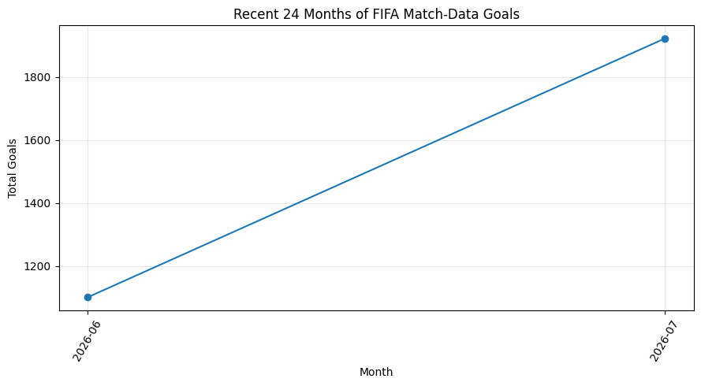
Interpretation:
The line chart shows the month-wise variation in total goals and helps identify increases, decreases, and changing goal patterns over the selected period.
Program 4 – Tournament-Stage Goal Aggregation
Step 1: Group the dataset by tournament_stage.
Step 2: Calculate the sum of goals for each tournament stage.
Step 3: Display the aggregated goal totals.
Program 4:
stage_goals=df.groupby("tournament_stage")["goals"].sum(); display(stage_goals)
Output:
The total goals for each tournament stage are displayed.
Program 5 – Total Goals by Tournament Stage Bar Chart
Step 1: Use the tournament-stage goal totals.
Step 2: Create a bar chart using bar().
Step 3: Add the title and axis labels.
Step 4: Rotate the stage labels and display the chart.
Program 5:
plt.figure(figsize=(8,5)); plt.bar(stage_goals.index.astype(str),stage_goals.values); plt.title("Total Goals by Tournament Stage"); plt.xlabel("Stage"); plt.ylabel("Total Goals"); plt.xticks(rotation=30); plt.tight_layout(); plt.show()
Output:
The bar chart titled “Total Goals by Tournament Stage” compares total goals across tournament stages.
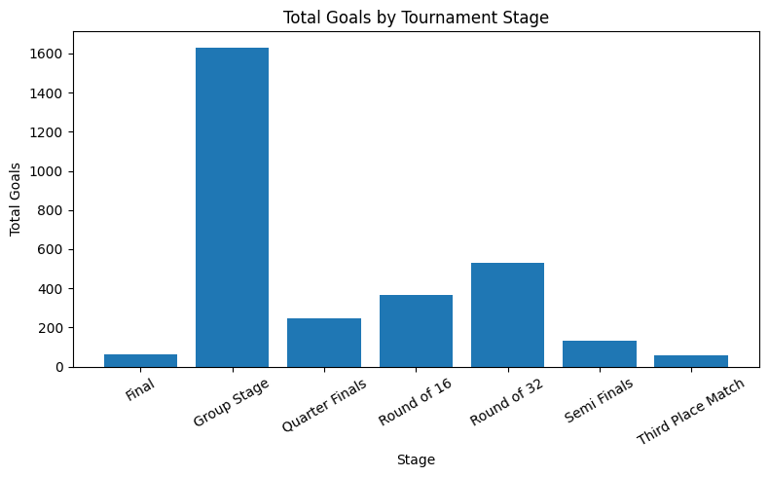
Interpretation:
The bar chart allows comparison of goal totals across the different tournament stages.
Program 6 – Goal Contribution by Position Pie Chart
Step 1: Group the dataset by player position.
Step 2: Calculate the total goals for each position.
Step 3: Create a pie chart using pie().
Step 4: Display position labels and percentage contributions.
Step 5: Add the chart title and display the figure.
Program 6:
w=df.groupby("position")["goals"].sum(); plt.figure(figsize=(7,7)); plt.pie(w.values,labels=w.index,autopct="%1.1f%%",startangle=90); plt.title("Goal Contribution by Position"); plt.tight_layout(); plt.show()
Output:
The pie chart titled “Goal Contribution by Position” shows the percentage contribution of each position to the total goals.
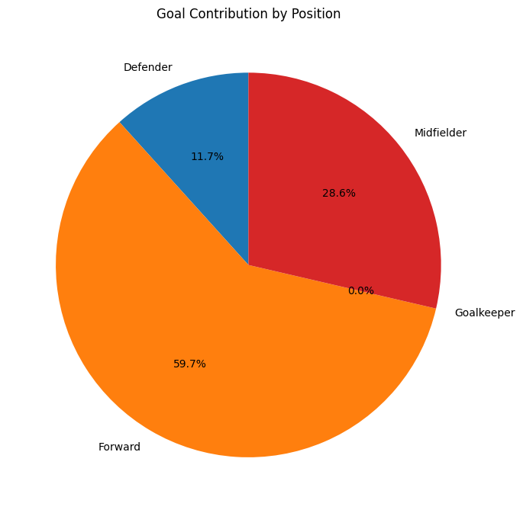
Interpretation:
The pie chart illustrates how total goals are distributed among player positions. Larger sectors represent greater goal contributions.
Program 7 – Player Rating Distribution Histogram
Step 1: Select the player_rating column.
Step 2: Create a histogram using hist() with 12 bins.
Step 3: Add the title and axis labels.
Step 4: Display the distribution of player ratings.
Program 7:
plt.figure(figsize=(8,5)); plt.hist(df["player_rating"],bins=12); plt.title("Player Rating Distribution"); plt.xlabel("Player Rating"); plt.ylabel("Number of Records"); plt.tight_layout(); plt.show()
Output:
The histogram titled “Player Rating Distribution” shows the frequency of player-rating values.
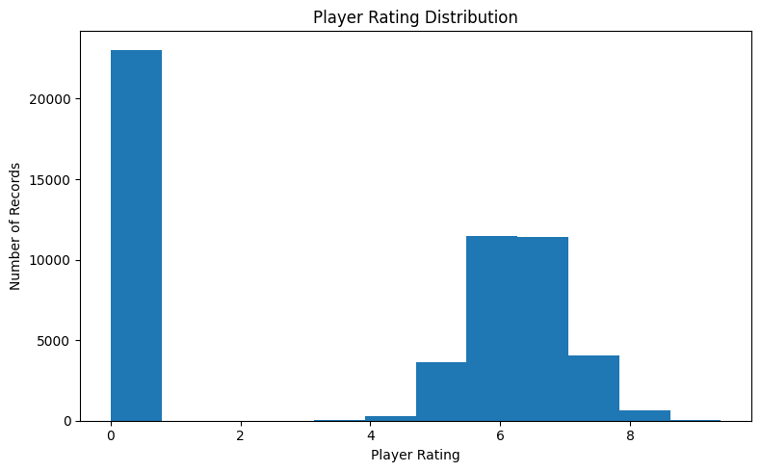
Interpretation:
The histogram helps understand the distribution and concentration of player ratings in the dataset.
Program 8 – Shots versus Expected Goals Scatter Plot
Step 1: Select a random sample of 5000 records using random_state=42.
Step 2: Plot shots on the X-axis and expected_goals_xg on the Y-axis.
Step 3: Use the scatter() function with transparency.
Step 4: Add a title and axis labels.
Step 5: Display the scatter plot.
Program 8:
sample=df.sample(5000,random_state=42); plt.figure(figsize=(8,5)); plt.scatter(sample["shots"],sample["expected_goals_xg"],alpha=.25); plt.title("Shots vs Expected Goals"); plt.xlabel("Shots"); plt.ylabel("Expected Goals (xG)"); plt.tight_layout(); plt.show()
Output:
The scatter plot titled “Shots vs Expected Goals” displays the relationship between shots and expected goals (xG).
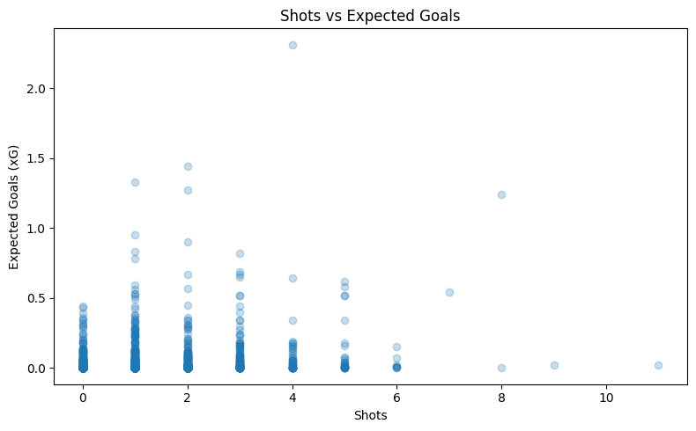
Interpretation:
The scatter plot helps observe the relationship and variation between the number of shots and expected-goal values.
Result
Thus, the FIFA World Cup 2026 player performance dataset was successfully analyzed using Pandas, and multiple visualizations were created using Matplotlib. The line chart, bar chart, pie chart, histogram, and scatter plot provide insights into monthly goals, tournament-stage goals, positional goal contribution, player-rating distribution, and the relationship between shots and expected goals.

